|  |
| --- |
| Team ID:PNT2022TMID44038 |

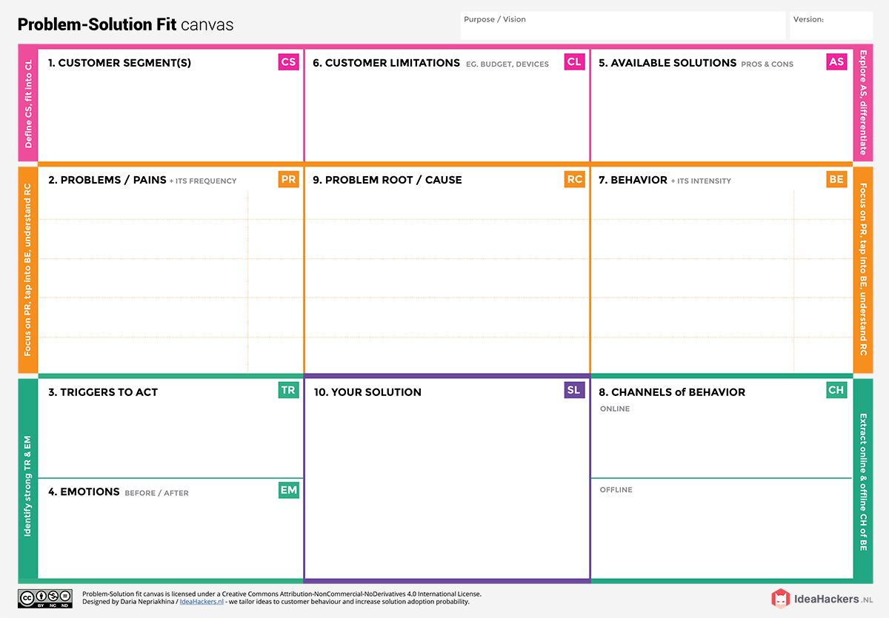

When they have disease they feel lonely, depressed and sad, they should develop hope that will overcome.

They can consult a doctor or undergo an master health checkup.

They can seek through the online websites etc to know about it.

Our solution is about to find who are affected by heart disease and those who are not. For this we are going through the people’s age ,gender and food habits to know about who are prone to heart disease. This can be done through data analytics.

Customer should seek for the advanced technology for solving their problem at low cost.

First of all they should tell what health issues they are undergoing. After that they should follow the guidelines given by the doctor.

The main reason for getting heart disease is high cholesterol , high blood pressure, smoking, depression, eating unhealthy foods and genetic related heart diseases.

It describes the mechanisms that cause a customer to adapt to an innovation. The person needs to recover from heart disease, no matter what were going to use, they need a solution to recover from the disease and to improve the health condition.

The proposed solutions are ECG for diagnosis of heart disease, most of all eating a fat, low salt diet, good sleep,avoid smoking.

We should focus on customer decision making process, highlighting the key moments from identifying the need to buy the product.

People those who are affected with the heart disease are said to be our customers and doctors who treat heart disease are also our customer.